

**HOST SITES NEEDED FOR SUMMER INTERNSHIP PROGRAM**

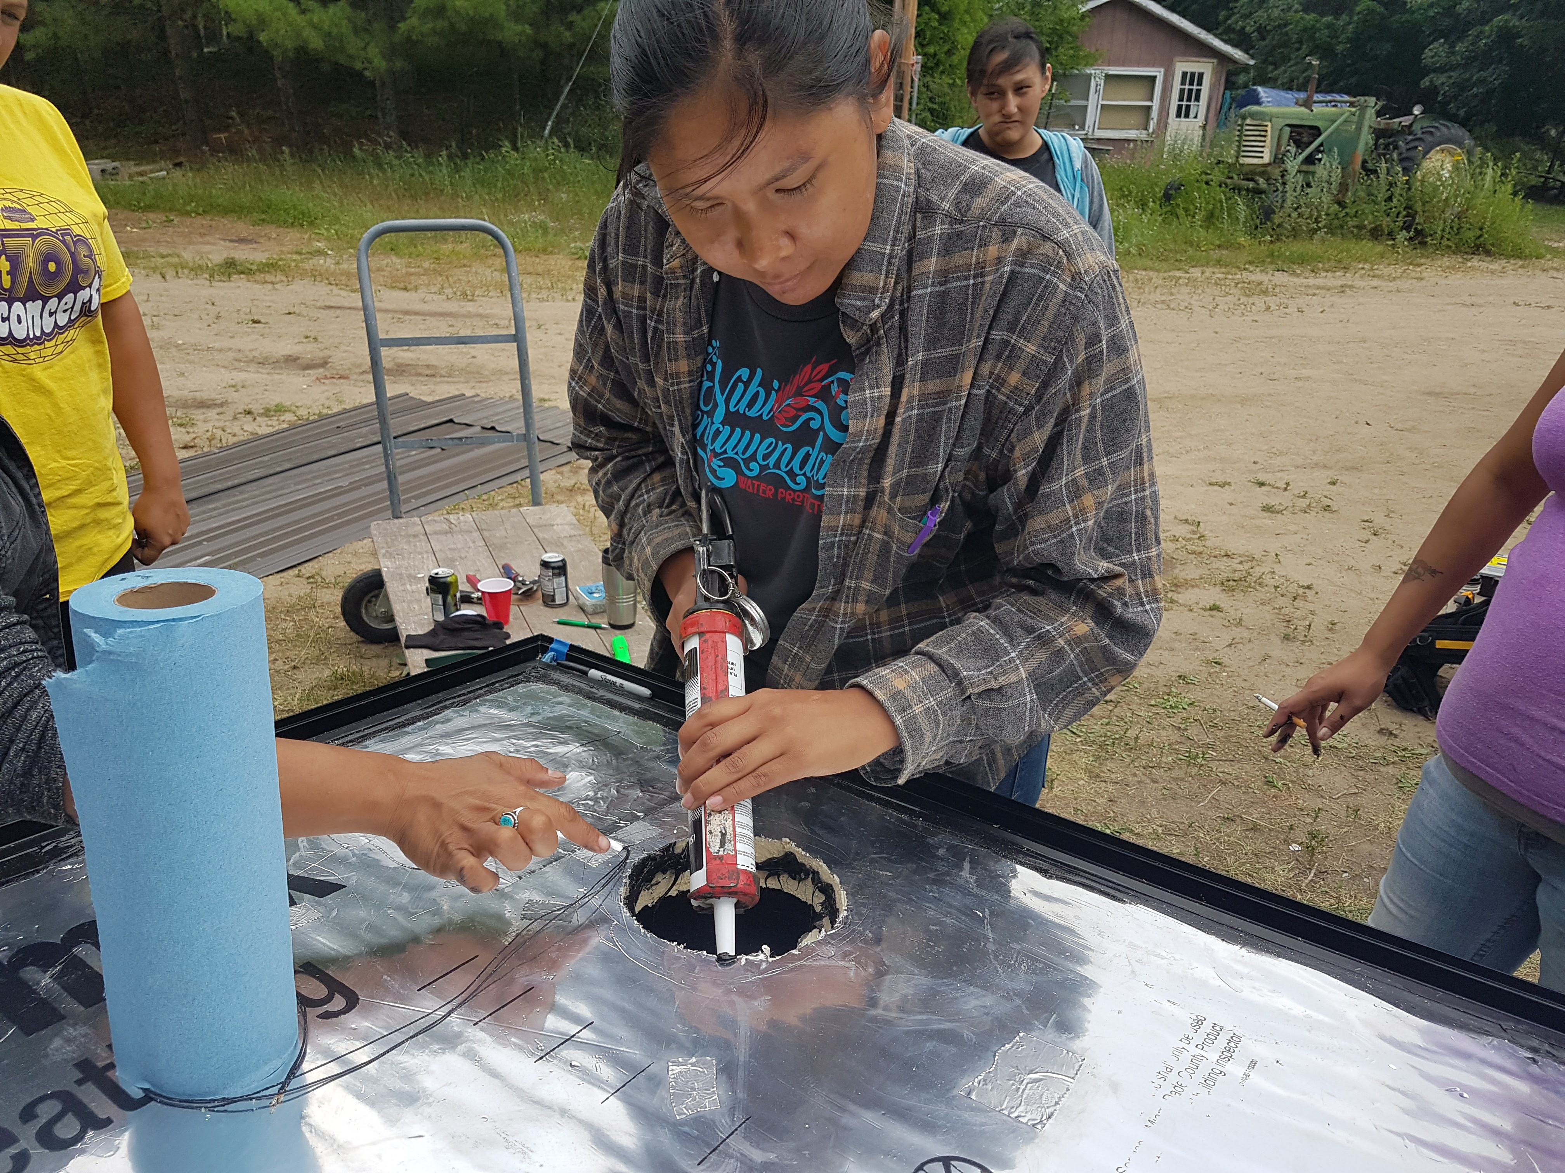The Institute for Tribal Environmental Professionals – Environmental Education Outreach Program at Northern Arizona University in Flagstaff, Arizona is seeking air quality focused offices and programs to host a college student for an 8-week summer internship. Tribal environmental offices, EPA offices, and other tribal environmental organizations are encouraged to apply.

The interns will be highly motivated undergraduate or graduate students majoring in environmental or related careers from different colleges and universities nationwide. ITEP provides each student intern with a $4,800 stipend. The host site provides a work place and supervision for the intern.

The projects MUST focus on addressing air quality issues in tribal communities.

2017 summer intern, Sherralyn Sneezer

**Submit an application** online at: <http://www7.nau.edu/itep/main/eeop/Internships/ssi_host>

**Deadline:** Apply by January 18, 2021.

If you know of a college student that might be interested in being an intern, encourage them to register at: [nau.edu/itepinterns](http://nau.edu/itepinterns)

For detailed information on the internship and requirements, visit our internship web-site: [nau.edu/itepinterns](http://nau.edu/itepinterns)

FOR MORE INFORMATION, PLEASE CONTACT:

**ITEP Intern Coordinator Josie Kamkoff**, Community Program Coordinator

[EEOP-INTERN@nau.edu](mailto:EEOP-INTERN@nau.edu) 928-419-1009 (Please leave a message)

Josephine.Kamkoff@nau.edu